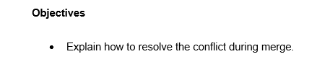

To resolve a conflict during a merge, first we must identify the conflicting files marked by the Git. Then open each file and manually edit the conflicting sections, clearly indicated by Git with conflict markers.

After resolving the conflicts, we remove the markers and save the changes. Then, stage the resolved files using git add and complete the merge with git commit.

This ensures that the repository reflects a consistent and conflict-free state.

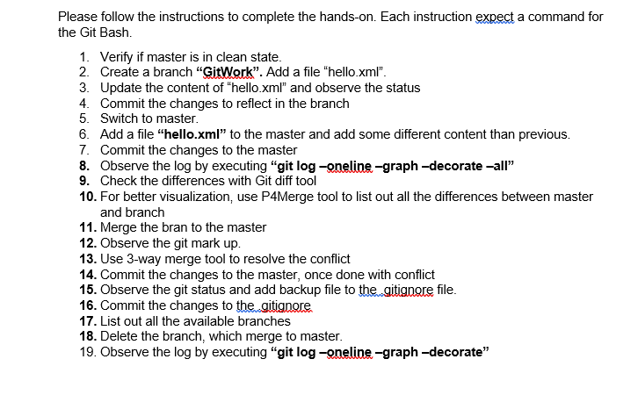

**Solution**

**Step 1**

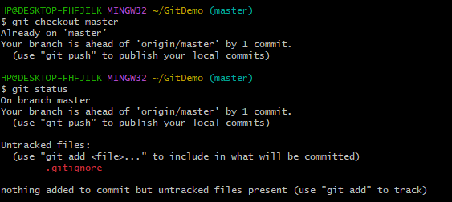

**Step 2**

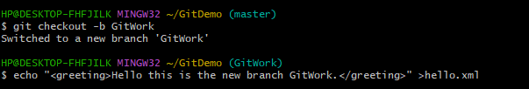

**Step 3**

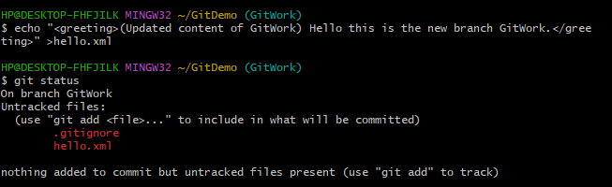

**Step 4**

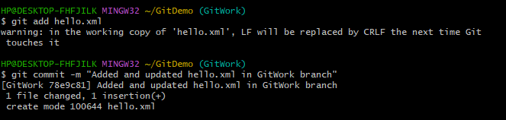

**Step 5**

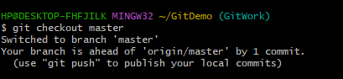

**Step 6**



**Step 7**

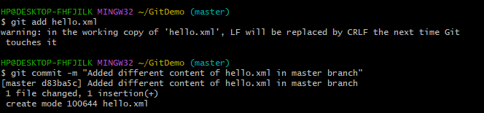

**Step 8**

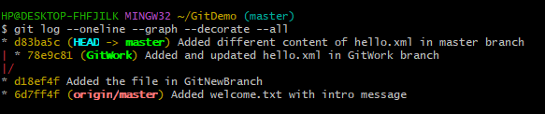

**Step 9**

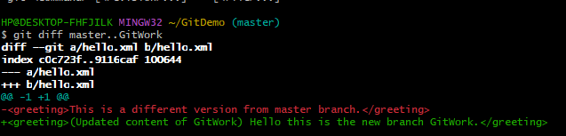

**Step 10**

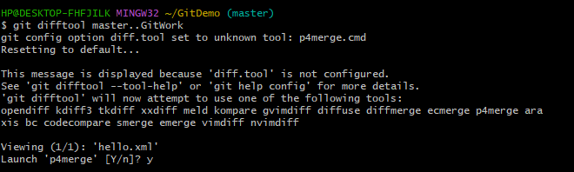

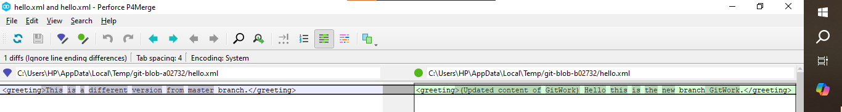

**Step 11**

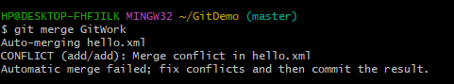

**Step 12**

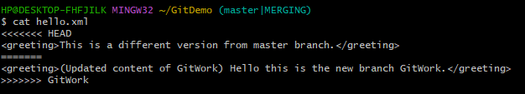

**Step 13**

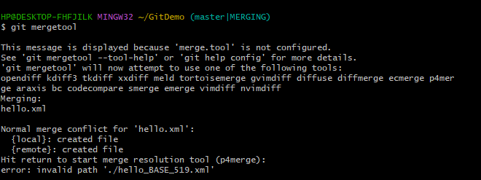

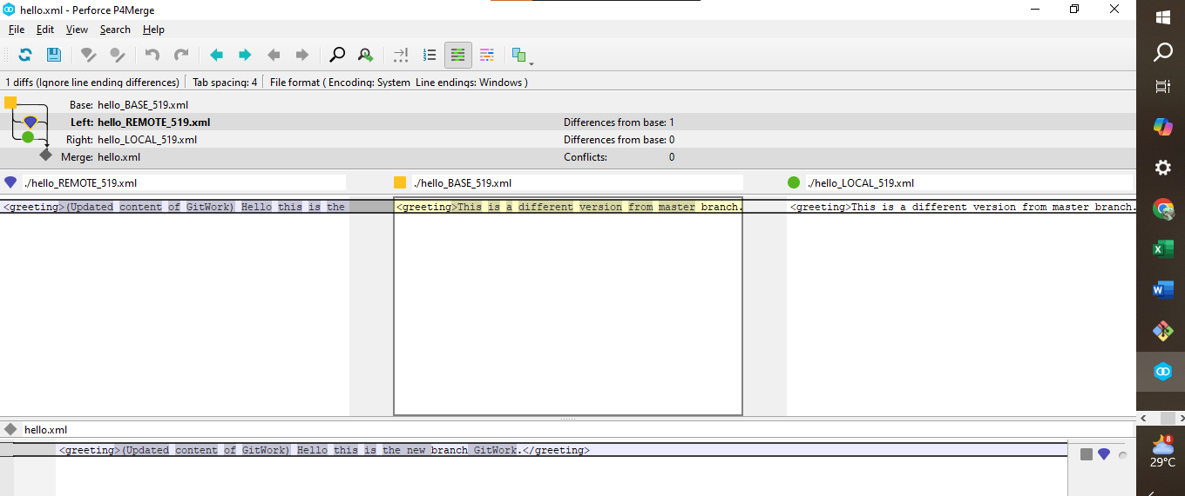

**Step 14**

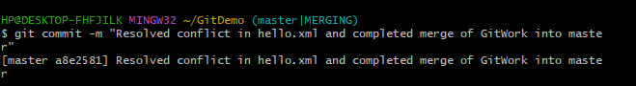

**Step 15**

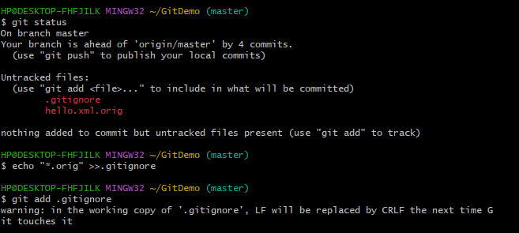

**Step 16**

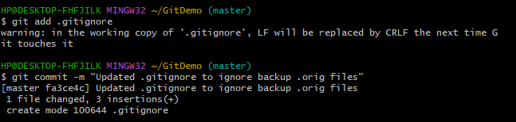

**Step 17**

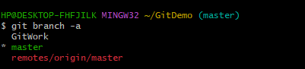

**Step 18**



**Step 19**

